Glossary

**mechanism** – a device used to create movement

**attach** – join or fasten something to an object

**force** – a push, pull or twist

**pivot** – to balance or turn about a point

**lever** – a card strip that moves around a pivot

**slider** – a rod or card strip that moves when pushed or pulled

**slot** – the hole through which a lever is placed

**scoring** – partly cutting through card to make it easier to fold

**guide bridge** –a piece of material that makes something go in the desired direction and keeps the mechanism in place

I Need to Know…

How to use of sliders and levers

Understand that different mechanisms produce different types of movement

Understand a simple slider and guide bridge mechanism

Know and use some of the technical vocabulary relevant to the project

**Outcome –** Sinking ship moving picture

**Design Criteria –**

* At least 1 moving part
* Mechanism strong enough to last
* Image that matches the event

Let’s Remember

Push, pull and twist are all types of forces that cause movement

Remember-Know - Explore



Explore Curriculum

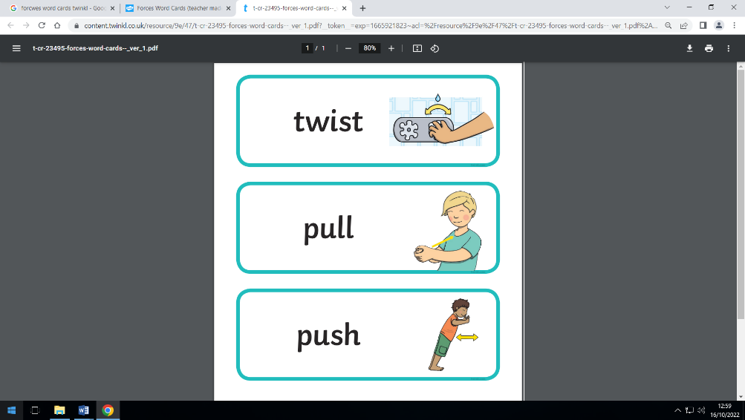

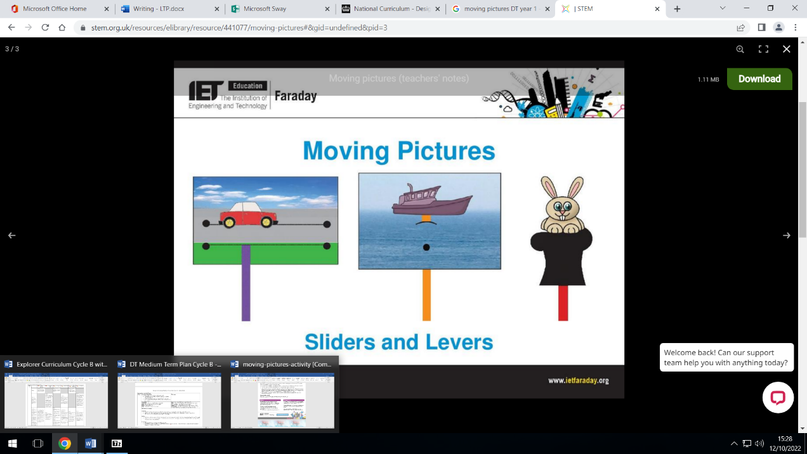

Design Cycle

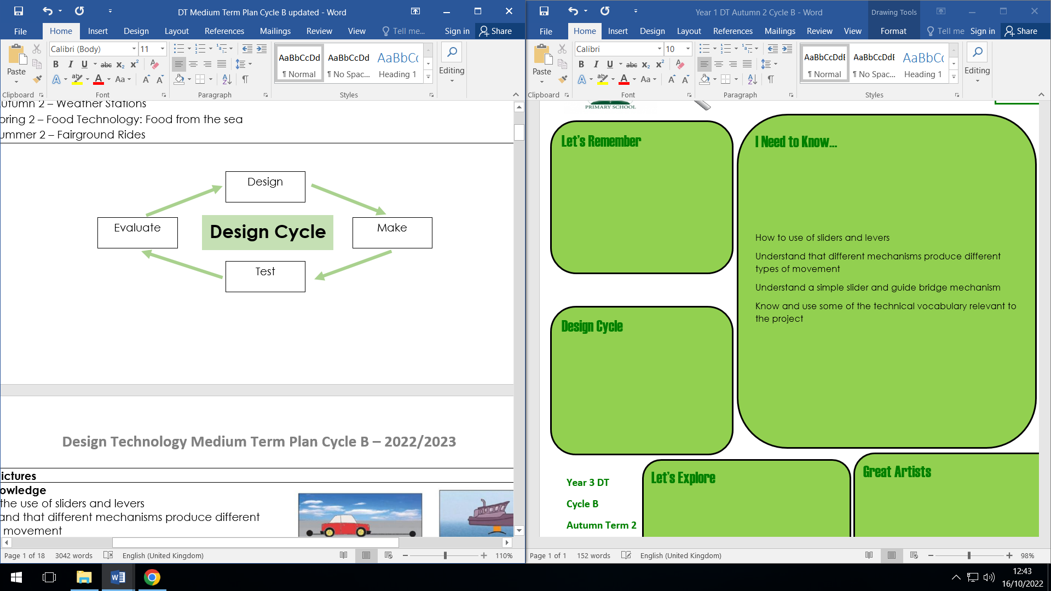

With these skills you could be…

Toy Designer – someone who is responsible for designing new toys either on their own or working for a toy company.

Let’s Explore

Create a greetings card that include levers or sliders

Tell a story using moving pictures that you have made

**Year 1 DT Mechanism**

**Cycle B**

**Autumn Term 2**