BADGER’S AUTUMN NEWSLETTER 2018
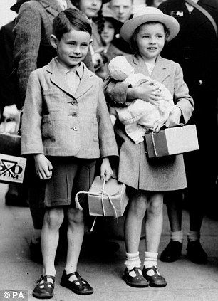
Dear Parents and Carers,
I hope you all had a fantastic summer break and are ready for an exciting, fun-filled autumn term in year 6! It has been great to get to know some of you over the past few weeks and I look forward to meeting all of you properly as the term progresses. The children are now starting to settle into new routines, topics and learning (as am I). We have an exciting year ahead!

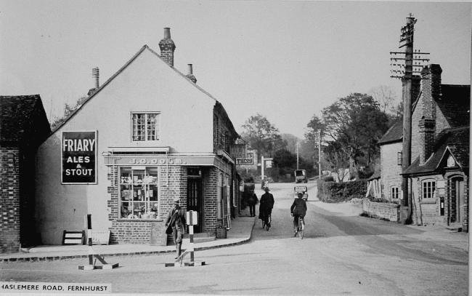
This term, we’re going on a historic journey back in time to World War 2 (WWII). We will discover how children were effected during the war, what their lives were like and how their lives were different to ours. Also, we will learn about the local area during WWII and look at all of the key events during WWII. We will be exploring and discovering a variety of sources that will inform us all about different aspects of the war. We will be doing plenty of Art, DT, Geography, as well as some emphatic PSHE looking at the emotional impact of WWII. In Maths, we’ll be building on our understanding of place value and number skills, whilst in English we’ll be writing diaries, narrative and possibly a non chronological report.

Working in Badger Class with me this year is Mrs Pafford! On Thursday afternoons, I have my Planning, Preparation and Assessment time out of class. For this half term, Mrs Gibbon will be teaching the children Music, where they’ll be learning the sounds and songs from WWII.

Guided Reading - We are reading Goodnight Mister Tom by Michelle Magorian and we have twelve copies in school. Please feel free to buy your child their own copy to enjoy in these sessions.

Targets - All children will be given targets for English and Maths to support their learning. Their targets will be changing frequently so it will be difficult to send them home. However, you are more than welcome to pop in and look at your child’s books to keep up to date with their learning.

Homework – I will be handing out homework on Mondays and should be handed in by Friday. Homework club will be every Thursday lunch time should your child wish to join. If your child repeatedly forgets to hand in their homework, they will be encouraged to attend homework club.

Spellings – I will send spellings home with the children every Monday (in their homework folder) and we will have regular spellings activities in school as well. There will be a formal spelling test the following Monday every week.

PE - PE kit is needed for Monday and Thursdays please. As the weather is changing, please ensure your child has warmer clothing as we will be outside in most weather conditions.

Parent volunteers who support our curriculum themes, reading and invaluable school trips are an essential asset to our school, that benefits children greatly. Please do get in touch if you think you can help in any way. If you have any first-hand experience related to our theme ‘A Child’s War’ which you would be happy to share with the children, please let me know!

If you have any concerns or wish to discuss anything about your child, please do not hesitate to come and see me. You can either catch me at the door (in the morning or after school) or alternatively leave a message at the office and I will get back to you as soon as possible.
We have an exciting year ahead of us with lots of interesting topics and opportunities which I know the children are excited about but also this is a very important year. I look forward to working with you and your child this academic year – I hope this will be a happy and successful year for everyone.

Best wishes,

Miss E Stocker

