23rd April 2019
Dear Parents / Carers,

Welcome to the Summer Term!

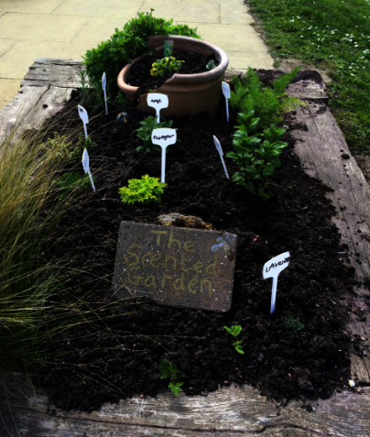
Last half term, we focused on ‘The Scented Garden’. The adjacent picture depicts Owls Class’ ‘Scented Garden’ which they planted in our outdoor area during the topic. The plants smell lovely! We also planted sunflowers (although only 8 have made it through the half term!) and planted potatoes, carrots, tomatoes and lettuce which are all growing well! We can’t wait to harvest our crops later in the Summer Term!
During the next five weeks in the run up to the Half Term Break, we will be turning our attention to a topic named ‘Street Detectives’. This is a theme where we’ll be learning about the process of construction, materials, types of homes as well as learn more about Fernhurst itself! We have a fabulous roleplay area on our patio where the children can be builders and we also have a few special visitors planned, including a workshop from the Brilliant Bricks team where we’ll attempt to make Fernhurst out of Lego! In Maths we’ll be looking at Mass Capacity and Temperature, before focusing on shapes, whilst in English we’ll be writing particulars to sell our own homes; creating our own versions of ‘On The Way Home’ by Jill Murphy and writing recounts! This is also the half term where we’ll be doing our SATS – we will be doing them in small, informal groups so there is not a high pressure environment, throughout the month of May. We are trying to keep them as stress free as possible!

On Wednesday afternoons, I have my Planning, Preparation and Assessment time out of class. For this half term, Mrs Gibbon will be teaching the children Computing, in addition to a weekly lesson with Mrs Bell. She and I are working closely together to maintain continuity during these periods and to ensure the children get as much out of this time as possible.

A few reminders for the half term:
- Fernhurst’s School Day: Whilst registration does not take place until 8:55am, the doors to the classroom open at 8.35am. During this time, the children have the opportunity to practice vital maths and english skills in the classroom, including times tables, spellings and maths, as well as take part in interventions with myself and Mrs Woods. Anyone arriving after 8.55am will be marked as late and will have missed up to 20 minutes of learning time!
- Named Jumpers: Please ensure that all of your child’s clothing is labelled (especially their school jumpers/cardigans). As the weather warms up over the coming weeks and months, the children will be taking their jumpers/cardigans off more and more regularly – we have a basket in class for them to put their jumpers in, but some are having difficulty identifying their own clothing as some are unnamed and all look very similar!
- Homework: Children should be continuing to read daily at home and practicing their spellings/times tables weekly. Spellings for each week will be given out at the beginning of each half term and will be tested on a Monday – I have also uploaded them to the Owls page on the school website in case the list goes astray. Even if your child is a Free Reader, it is really important in Year 2 that all children continue to be reading at home every day with an adult or older sibling and that this is recorded in their reading record –this could be their school reading book or a book from home.
- Water Bottles: The children get thirsty as they have an energetic day and benefit from a drink to maintain their focus and boost their energy. If you do not already, please provide your child with a full water bottle separate to their lunch box drink.

How to help your child at home this half term:
- Reading – Please record any reading that your child does at home (including books which are not sent home from school) in their reading record as this provides fantastic evidence of what the children are reading away from school. In the Autumn Term, I stuck a list of questions into the back of the children’s reading records. If you could aim to once a week to ask your child one of these questions when reading and record it in their reading record, that would be amazing!
- Writing – Writing for real purposes is meaningful and rewarding for children and creates a fun and interesting way for children to develop their writing skills. If your child does any ‘Street Detectives’ themed writing, please encourage them to bring them into school to share with their peers.
- Maths – Last half term, the children were introduced to telling the time. At this stage, they need to be able to identify o’clock, quarter past/to, half past, before progressing onto telling the time to the nearest five minutes as the year goes on. Any practice of reading analogue clocks and watches that you can do at home is hugely beneficial to your child’s learning and of course, they will need this skill for the whole of their lives so it’s really important to embed it now!

The children enjoy and greatly benefit from volunteers who support our curriculum themes, reading and school trips. Please get in touch if you think you can help this half term!

Please don’t hesitate to come and see me if you have any concerns or wish to discuss anything about your child. You can catch me at the door (in the morning or after school) or alternatively leave a message at the office and I will get back to you as soon as possible.

Thank you for your continued support!

Yours sincerely,

Miss A Barnes
Owls Class Teacher

