25th February 2019
Dear Parents / Carers,

Welcome to the second half of the Spring Term - I hope you all enjoyed the half term break and that your children are feeling refreshed ready for lots of new learning!
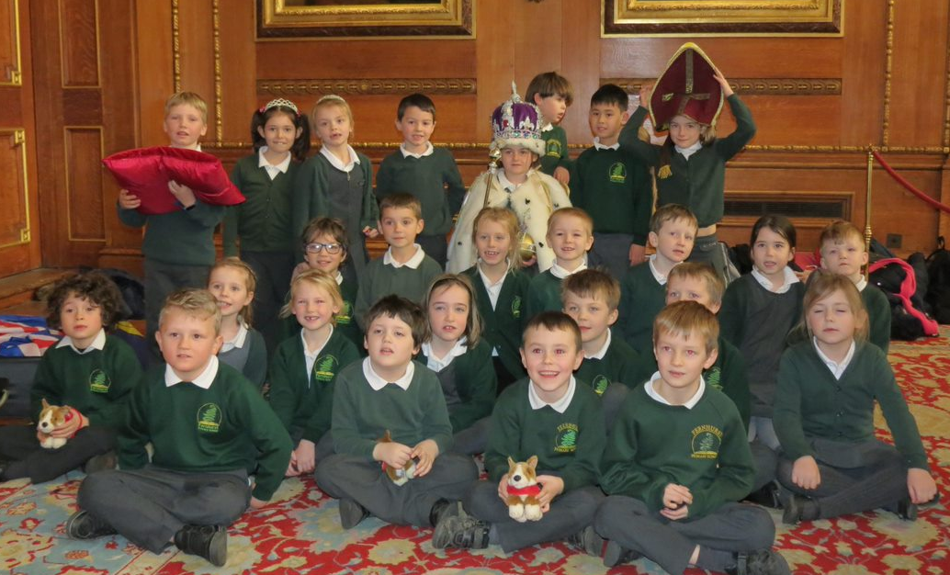

Our topic ‘Towers and Turrets’ was a real highlight of the year so far for me and Mrs Woods. The picture above depicts Owls Class in the Waterloo Chamber of Windsor Castle during our Workshop – we were given special permission to take some photos of the class during the workshop as normally cameras are banned inside! Finally for this topic, we are in the midst of preparing for our assembly to you all on Wednesday morning where the children will tell you all about our learning – we look forward to seeing many of you there!

During the next six weeks in the run up to the Easter Holidays, we will be turning our attention to a topic named ‘The Scented Garden’. This is a science focused topic where we’ll be learning about plants and how they grow – later this week we’ll be planting our own herby ‘Scented Garden’ outside our classroom, taking part in a sunflower growing competition and planting some vegetables in our propagators so we can learn lots about growing! In Maths we’ll be developing our understanding of statistics and shapes, as well as starting our work on Telling the Time; whilst in English we’ll be writing our own ‘Percy the Park Keeper’ stories, crafting instructions for growing flowers and creating our own weird and wonderful plants to write about too!

On Wednesday afternoons, I have my Planning, Preparation and Assessment time out of class. For this half term, Mrs Gibbon will be teaching the children Music and RE, with a focus on Easter, in addition to a weekly Geography lesson with Mrs Bell. She and I are working closely together to maintain continuity during these periods and to ensure the children get as much out of this time as possible.

A few reminders for the half term:
- Fernhurst’s School Day: Whilst registration does not take place until 8:55am, the doors to the classroom open at 8.35am. During this time, the children have the opportunity to practice vital maths and english skills in the classroom, including times tables, spellings and maths, as well as take part in interventions with myself and Mrs Woods. Anyone arriving after 8.55am will be marked as late and will have missed up to 20 minutes of learning time!
- Homework: Children should be continuing to read daily at home and practicing their spellings/times tables weekly. Spellings for each week will be given out at the beginning of each half term and will be tested on a Monday – I have also uploaded them to the Owls page on the school website in case the list goes astray.
- PE: This half term, there is no Forest School. We will be doing PE sessions on Monday and Friday mornings. Please ensure your child has their PE kit first thing on Monday morning ready for this, we’ll endeavor to send them home on a Friday afternoon! We are going to try and get outside more this half term in PE so please ensure your child has jogging bottoms or something similar so they can stay warm if it’s chilly!
- Water Bottles: The children get thirsty as they have an energetic day and benefit from a drink to maintain their focus and boost their energy. If you do not already, please provide your child with a full water bottle separate to their lunch box drink.

How to help your child at home this half term:
- Reading – Please record any reading that your child does at home (including books which are not sent home from school) in their reading record as this provides fantastic evidence of what the children are reading away from school. In the Autumn Term, I stuck a list of questions into the back of the children’s reading records. If you could aim to once a week to ask your child one of these questions when reading and record it in their reading record, that would be amazing!
- Writing – Writing for real purposes is meaningful and rewarding for children and creates a fun and interesting way for children to develop their writing skills. If your child does any ‘Scented Garden’ themed writing, please encourage them to bring them into school to share with their peers.
- Maths – This half term, the children will be introduced to telling the time. At this stage, they need to be able to identify o’clock, quarter past/to, half past, before progressing onto telling the time to the nearest five minutes as the year goes on. Any practice of reading analogue clocks and watches that you can do at home is hugely beneficial to your child’s learning and of course, they will need this skill for the whole of their lives so it’s really important to embed it now!

The children enjoy and greatly benefit from volunteers who support our curriculum themes, reading and school trips. Please get in touch if you think you can help this half term!

Please don’t hesitate to come and see me if you have any concerns or wish to discuss anything about your child. You can catch me at the door (in the morning or after school) or alternatively leave a message at the office and I will get back to you as soon as possible.

Thank you for your continued support!

Yours sincerely,

Miss A Barnes
Owls Class Teacher

