Glossary

**textiles** - Textiles are flexible materials which are woven from fibres which are used to make clothing, sheets, towels carpets

**sew/stich** – a loop of thread or yarn resulting from a single pass or movement of the needle in sewing, knitting or crocheting

**aesthetics** – aesthetic is used to talk about beauty or art, and people’s appreciation of beautiful things

**template** – a shaped piece of rigid material used as a pattern for processes such as cutting out and shaping

**running stitch** - creating a dotted line effect

**back stitch** - thread double backed and no visible spaces in between stitches

**over sew** - neaten the edges of the fabric

**blanket stitch** - reinforce the edges of thick material

**attach** – join or fasten something to an object

I Need to Know…

how to use a range of stitches

that different fabrics and decorative items can be joined to create a textile product

understand that using a template (or paper pattern) helps to accurately mark out a design on the fabric

understand the importance of consistancy when stitching as this is more aesthetically pleasing as well as pulling them taut to make the joins secure and strong.

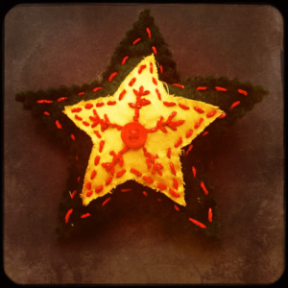

**Outcomes –** A seasonal decoration that they can be gifted to a friend/relative

**Design Criteria –**

* aesthetically pleasing
* matches the seasonal time
* fit for purpose
* assembled accurately and well finished

Let’s Remember

I can join two pieces of card with glue.

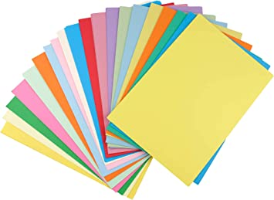

Remember-Know - Explore



Explore Curriculum

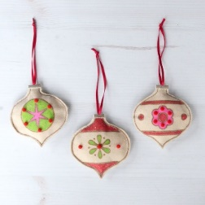

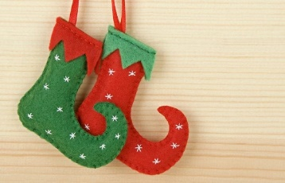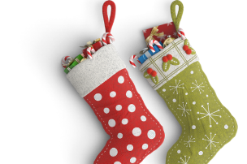

Design Cycle

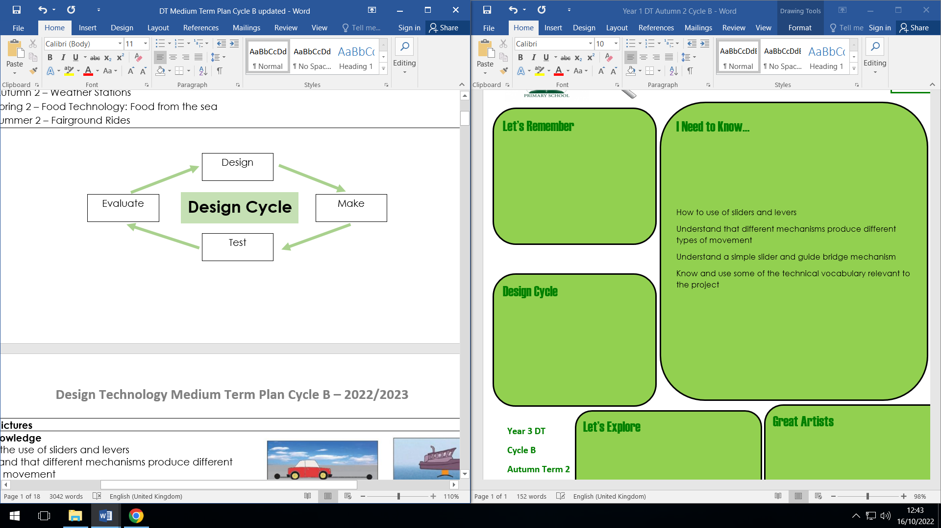

With these skills you could…

Fashion designer – a fashion designer designs and assists with the production of clothing, shoes and accessories, identifies trends, and selects styles, fabrics, colours, prints and trims for a collection.

**Year 4 DT Textiles**

**Cycle B**

**Autumn Term 2**

Let’s Explore

Make more seasonal decorations using different materials and stitches.

How could you make decoration suitable to stay outside?